AI Course
Team Project Final Report

For students (instructor review required)

ⓒ2019 SAMSUNG. All rights reserved.
Samsung Electronics Corporate Citizenship Office holds the copyright of this document.
This document is a literary property protected by copyright law so reprint and reproduction without permission are prohibited.
To use this document other than the curriculum of Samsung innovation Campus, you must receive written consent from copyright holder.

Medical Insurance Cost Prediction Using SVR

Regression, Ridge Regression, Lasso Regression, and

Ensemble Methods

29 March 2022

Troubleshooters

Eng. Nouf AlQahtani
Amal Alsulami
Lujain Almoqren

Content

1. Introduction
1.1. Background Information
1.2. Motivation and Objective
1.3. Members and Role Assignments
1.4. Schedule and Milestones

2. Project Execution
2.1. Data Acquisition
2.2. Training Methodology
2.3. Workflow Diagram
2.4. System Diagram

3. Results
3.1. Data Preprocessing
3.2. Exploratory Data Analysis (EDA)
3.2.1. Age vs. Charges
3.2.2. Region vs. Charges
3.2.3. Number of Children vs. Charges
3.2.4. Smoker and Sex vs. Charges
3.2.5. BMI vs. Charges
3.3. Modelling
3.4. Testing and Improvements

4. Projected Impact
4.1. Accomplishments and Benefits
4.2. Future Improvements

5. References

6. Team Member Review and Comment

7. Instructor Review and Comment

1. Introduction

1.1. Background Information
Predicting medical insurance cost is a valuable tool for improving healthcare accountability. In general, health insurance is a policy that covers the losses expenses caused by a variety of hazards [1], and its cost is affected by several factors, such as age and history of diseases. Nowadays, the rising cost of medical insurance is one of the world's most significant problems. Therefore, forecasting such costs with high accuracy is a significant move to address this problem. It is a necessary step to improve healthcare budget management [2].

Machine learning (ML) is classified into three different types, as shown in Figure 1. The first type is supervised machine learning which is mainly used for classification or regression and all labeled data. The second type is unsupervised machine learning which is used for clustering and all unlabeled data. The last one is reinforcement learning which is used for decision making. In this study, we used supervised machine learning models to demonstrate and compare the accuracy of various regression models, including Linear Regression (LR), Support Vector Regression (SVR), Ridge Regression (RR), and Lasso Regression.

Many studies have been conducted in this area of interest since the 1980s. These studies indicated the importance of developing predictive models of medical costs based on health insurance using heuristic rules and regression methods. However, most of these studies used the simple linear regression technique for prediction. They did not highlight the other regression models, including SVR, Ridge, and Lasso. For this reason, in this work, we developed a predictive algorithm for the cost of medical insurance using SVR, Ridge, and Lasso regression analysis techniques. Then, we used ensemble methods to produce more accurate solutions than a single model would. We used the published data of medical insurance for training the algorithm to provide rigorously validated predictions of healthcare costs in the future. Finally, we evaluated and compared the results of each model to find the best prediction model.

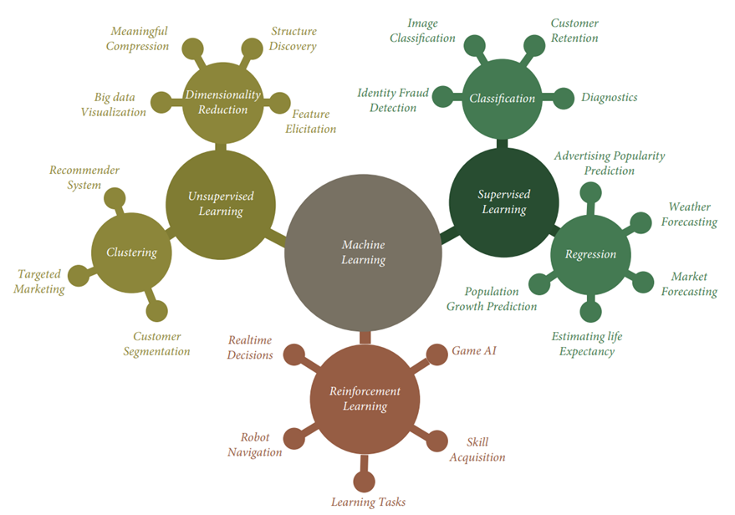

Figure 1: Types of Machine Learning [1]

1.2. Motivation and Objective
Since most of the conducted studies to predict medical costs used the simple linear regression technique for prediction, we aim to use other types of linear regression for medical insurance forecasting. The main goal of this project is to evaluate different types of regression analysis for predicting medical insurance costs. Our purpose is to find the best regression technique for predicting medical insurance cost by comparing different types of regression analysis for medical insurance cost prediction.

1.3. Members and Role Assignments

Table 1: Members and Role Assignments

Name | Role | Description
Nouf | Team Leader | Nouf will provide guidance, instruction, and leadership to the team to achieve key results. Besides, she will train the second model, develop an ensemble method, evaluate the performances, and participate in report writing.
Amal | Team Player | Amal will actively contribute to the project by preprocessing data, training the first model, and participating in report writing.
Lujain | Team Player | Lujain will actively contribute to the project by training the third model, performing exploratory data analysis, visualization, and participating in report writing.

1.4. Schedule and Milestones

Table 2: Schedule and Milestones

Project Phases | Status
Phase 1: Project Initiation
Formulating Project Group | Complete
Selecting the Research Area | Complete
Set kick-off meeting | Complete
Phase 2: Project Definition and Planning
Defining the Problem | Complete
Formulating Project Aim and Objectives | Complete
Conducting the Literature Review | Complete
Planning the Solution | Complete
Selecting Data Collection Methods | Complete
Submitting Project Action Plan 1st Edition | Complete
Submitting Project Action Plan Final Edition | Complete
Phase 3: Project Execution and Implementation
Collecting and Preprocessing the Data | Complete
Model Selection | Complete
Coding the Program (Developing Regression Algorithms) | Complete
Data analysis and Model Training | Complete
Selecting and Developing Ensemble Methods | Complete
Testing the Program | Complete
Phase 4: Project Control
Evaluation of Project Output | Complete
Reaching Conclusions | Complete
Documenting the Program | Complete
Phase 5: Project Closing
Finalize Project Report | Complete
Deliver the Project | Complete
Project Presentation | Complete

2. Project Execution

2.1. Data Acquisition
The data set is obtained through the Kaggle site [3] to design the medical insurance cost model predictor. There are seven attributes in the data set, as illustrated in Table 3. After obtaining the data set, it was separated into two parts, which are the training data part and the test data part. 70% of total data is used for training data, and the remaining for test data. The main use of the test set is to evaluate the regression model, while the training data set is used to build a model as a predictor of medical insurance cost.

Table 3: Dataset Description

Name | Description | Value
Age | Age of the client | It has an integer value (18 – 64)
Sex | Insurance contractor gender (Female/Male) | Female: 1  Male: 0
BMI | Body mass index, providing an understanding of body, weights that are relatively high or low relative to height | An objective body weight index (kg/m²) based on the height-to-weight ratio (15.96 – 53.13)
Children | Number of children covered by health insurance / Number of dependents | It has an integer value (0 – 5)
Smoker | Whether a client is a smoker or not. | Non-Smoker: 0  Smoker: 1
Region | The client residential area in the US (Northeast/ Southeast/ Southwest/ Northwest) | Northeast: 0  Northwest: 1  Southeast: 2  Southwest: 3
Charges (Target Variable) | Individual medical costs billed by health insurance | It has rational value

2.2. Training Methodology
The machine learning techniques were performed on medical insurance data that obtained from Kaggle. But first, the data was preprocessed and cleaned to eliminate incorrect, redundant, or incomplete data and convert data into a suitable form for further processing and analysis. This stage is necessary to achieve the highest quality data. After preprocessing, the features were selected by performing feature engineering. According to feature engineering and correlation matrix, attributes such as a smoker, BMI, and age are the most significant factors that affect charges. Since the region does not affect the charges, we drop it as it has less correlation with other features, as shown in Figure 2. Next, the data set is split into two parts, train and test data sets. To perform regression on the data, the categorical values are converted to numerical values, as illustrated in Table 1. Then, regression models and ensemble methods were developed using Python language and applied to the data to perform the needed analysis of potential predictions of medical insurance costs. These models are trained, analyzed, and evaluated closely.

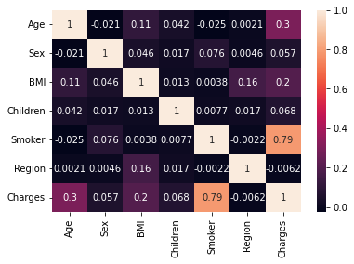
Figure 2: Correlation Matrix with a Heat Map

2.3. Workflow Diagram
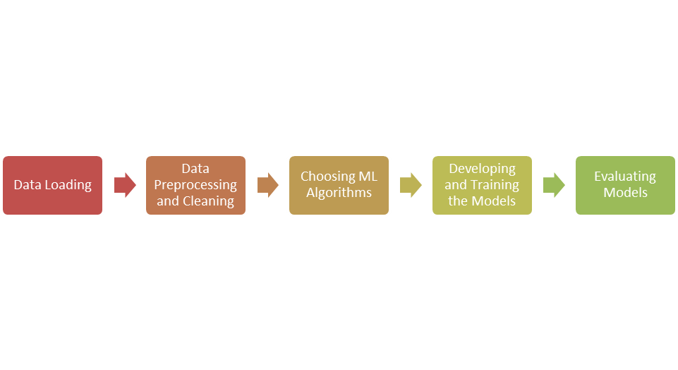
Figure 3: Workflow Diagram

2.4. System Diagram
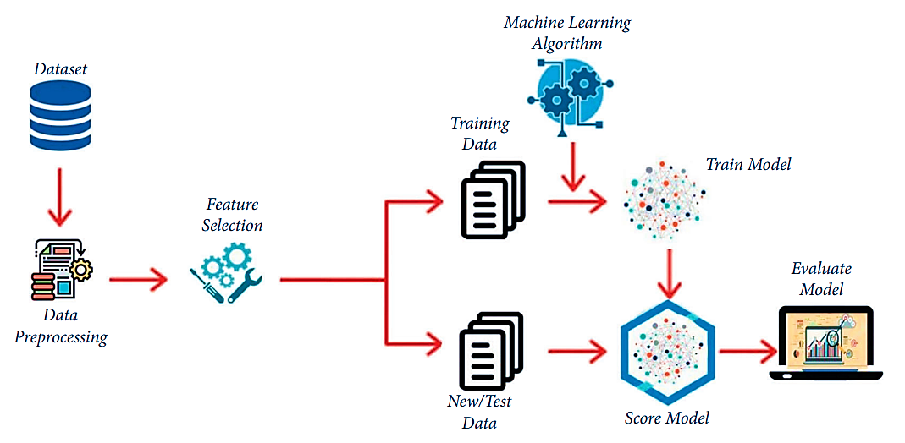

Figure 4: System Diagram

3. Results

3.1. Data Preprocessing
​The data set was preprocessed to make the features suitable for the model and achieve better results. There were no null values in the data set. Moreover, the categorical features ('sex' and 'region') are encoded. The sex feature is encoded using Label Encoding as there are only two categories, while the region feature is encoded using One Hot Encoding as there are more than two categories. After that, the selected features are scaled to normalize their range in the data, as shown in Figure 5.
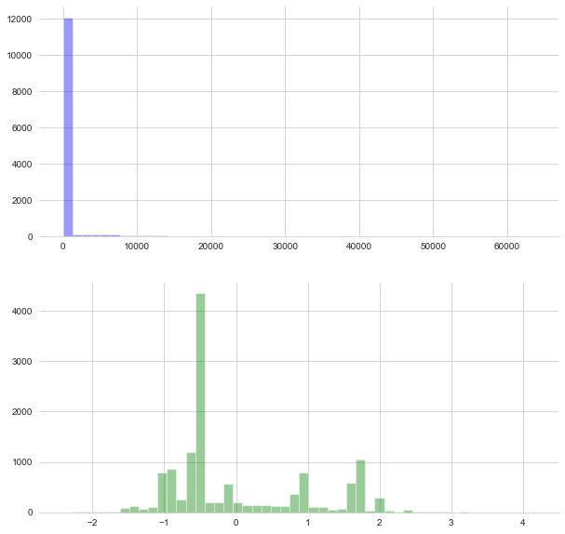

A
B

Figure 5: (A) Data Distribution before Normalization (B) Data Distribution after Normalization

3.2. Exploratory Data Analysis (EDA)
The exploratory data analysis was performed to plot features versus feature (charges) for data visualization.

3.2.1. Age vs. Charges
Figure 6 shows that as age increases, the insurance charges increase since the probability of health problems rises as age increases. For example, when the age touches 64, the insurance charge reaches $512,062.
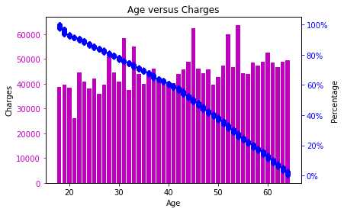

Figure 6: Age versus Insurance Charge Features

3.2.2. Region vs. Charges
Insurance charges change regarding regions, as shown in Figure 7. The Southeast region has the highest insurance charges than other regions following the Northwest, Northeast, and Southwest.
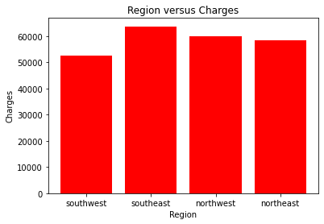

Figure 7: Regions versus Insurance Charge Features
3.2.3. Number of Children vs. Charges
Figure 8 shows that the insurance charges are more likely to decrease as the number of children increases. However, the size of the family does not necessarily determine insurance cost. For instance, a healthy family of five children could spend less than a married couple with chronic conditions. So, these factors are not enough to find the relationship between the number of children and insurance charges.

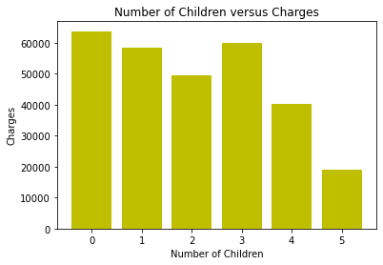
Figure 8: Number of Children versus Insurance Charge Features

3.2.4. Smoker and Sex vs. Charges
Normally medical insurance cost is high for smokers because they are more likely to have cancer and respiratory diseases. Furthermore, since men are more addicted to and passionate about smoking compared to women, the health insurance cost for females is greater. Figure 9 shows that the insurance charges decrease for men and increase for women as smoking habits increase. Moreover, women always pay higher medical insurance than men.

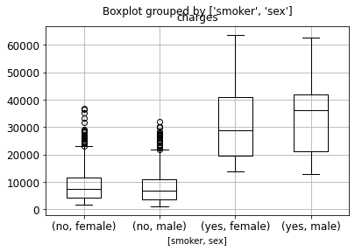
Figure 9: Smoker and Sex versus Insurance Charge Features

3.2.5. BMI vs. Charges
It clearly appears that as the BMI values are varied, the insurance charges will vary accordingly, as shown in Figure 10. Typically, insurance charges raise in case of overweight or obese since these cases can lead to serious health issues.

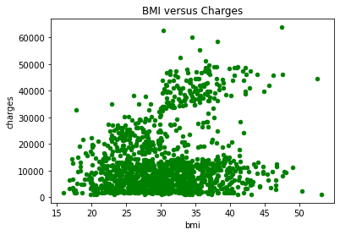
Figure 10: BMI versus Insurance Charge Features

3.3. Modeling
In Figure 11, the R2 score value of all machine learning algorithms is visualized for better understanding. By comparing the R2 score value of these ML models, in comparison to the other ML models, SVR provides a high R2 score value of 0.88. By comparing the performance of all these machine learning algorithms, we conclude that all models showed high-quality results, and these models achieved almost an average accuracy of 71%, as illustrated in Table 4.

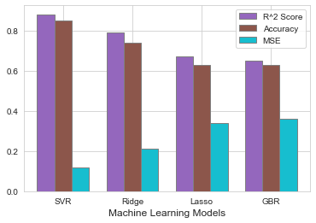
Figure 11: Evaluation of Designed Machine Learning Models

Table 4: Outcomes of Machine Learning Models

Model | R² Score | Accuracy | MSE
SVR | 0.88 | 0.85 | 0.12
Ridge | 0.79 | 0.74 | 0.21
Lasso | 0.67 | 0.63 | 0.34
GBR | 0.65 | 0.63 | 0.36
Average Calculations | 0.75 | 0.71 | 0.26

3.4. Testing and Improvements
Implementation of machine learning models needs a planned approach to ensure high-quality outcomes. During this project, a specific test-oriented management approach, as shown in Figure 12, was developed to improve the quality of developed models. Considering this approach helps us to develop the required model with an average accuracy of 71%.

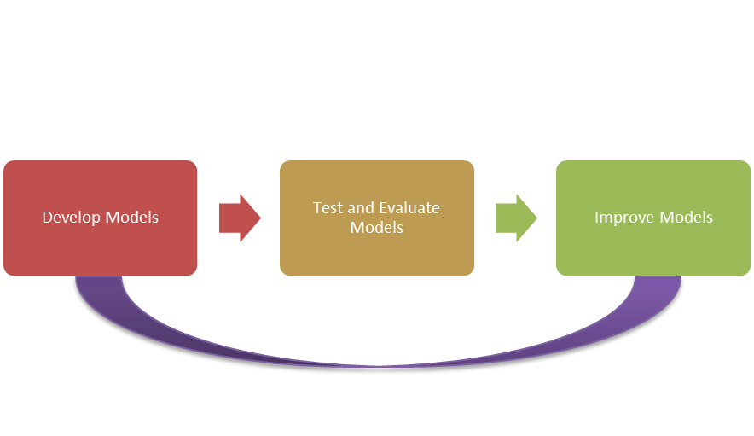
Figure 12: Test-Oriented Management Approach

4. Projected Impact

4.1. Accomplishments and Benefits
In this project, by using a set of ML algorithms, a computational intelligence approach is applied to predict healthcare insurance costs. The resultant outcome revealed that SVR achieved a high accuracy of 85% with an MSE score of 0.12. The main achievements in this project include evaluating different types of regression analysis to predict the costs of medical insurance and obtaining reliable outcomes. This project has benefits in predicting medical insurance costs using machine learning models. It helps to solve the predicted cost of medical insurance resulting in better management of the healthcare budget.

4.2. Future Improvements
In future work, we will use other algorithms for improvement purposes. Also, we will consider deep learning approaches on multiple medical health-related datasets. Besides, we will increase the amount of data to increase the credibility of the research using aggregation methods that work to achieve results with high accuracy.

5. References

[1] Ch. A. ul Hassan, J. Iqbal, S. Hussain, H. AlSalman, M. A. A. Mosleh, and S. Sajid Ullah, ‘A Computational Intelligence Approach for Predicting Medical Insurance Cost’, Mathematical Problems in Engineering, vol. 2021, pp. 1–13, Dec. 2021, doi: 10.1155/2021/1162553.
[2] ‘(PDF) Predict Health Insurance Cost by using Machine Learning and DNN Regression Models’. https://www.researchgate.net/publication/348559741_Predict_Health_Insurance_Cost_by_using_Machine_Learning_and_DNN_Regression_Models (accessed Mar. 26, 2022).
[3] ‘Medical Cost Analysis (Regression)’. https://kaggle.com/danaelisanicolas/medical-cost-analysis-regression (accessed Mar. 28, 2022).

6. Team Member Review and Comment

NAME | REVIEW and COMMENT

7. Instructor Review and Comment

CATEGORY | SCORE | REVIEW and COMMENT
IDEA | __/20
CODING | __/20
PROJECT  MANAGEMENT | __/30
PRESENTATION & REPORT | __/30
TOTAL | __/100

